[Show me](https://www.youtube.com/watch?v=V3eOuK_-c34) the pictures

by José Carlos Duarte

December, 2016

Show me the picture is an application created to see the pictures from your library or copy them to a folder or memory sharing with friends.

In digital age, people have thousands of picture files in the computer and it’s not possible to take all of them to your mobile or small memory laptop used for showing them. Also, it’s a time consuming to decide which one to show.

Show me the pictures makes easier these tasks.

See instructions next pages and enjoy.

To start you will need to install Java.

Java can be installed from:



Add java.exe to your path and use the command according.

To list all picture files

*Java Main <picture_folder>*

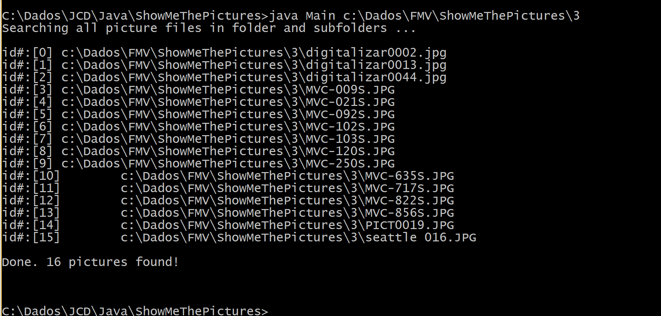

You can see above that every picture will have an ID assigned. These IDs can be used to create a file with IDs to copy files like you will see next command options.

To shuffle some picture files to show

*Java Main show <pict_folder> <interval time> <num.pictures>*

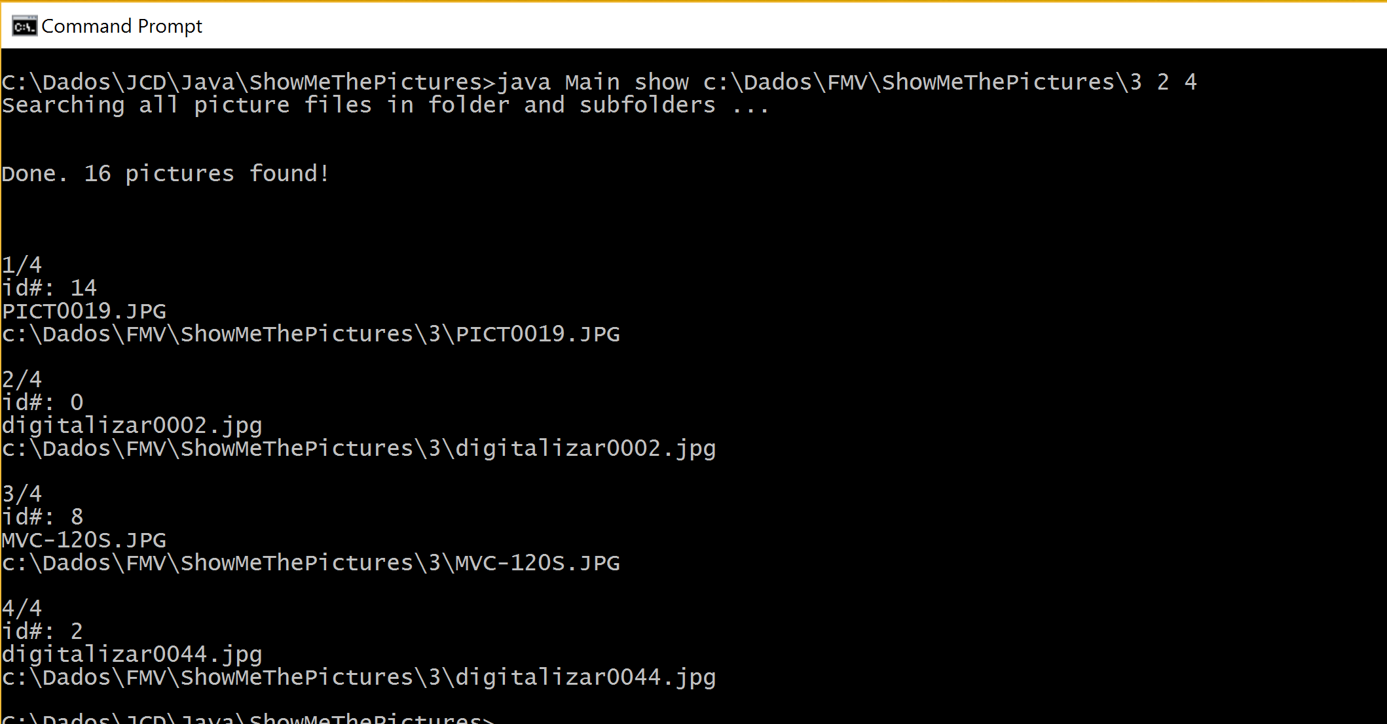

In the sample above 4 random picture files were selected to display every 2 seconds.

To show all picture files under a folder

*Java Main show <pict_folder> <interv. time> <numb.times> ALL*

To show all picture files every second, twice we can run:

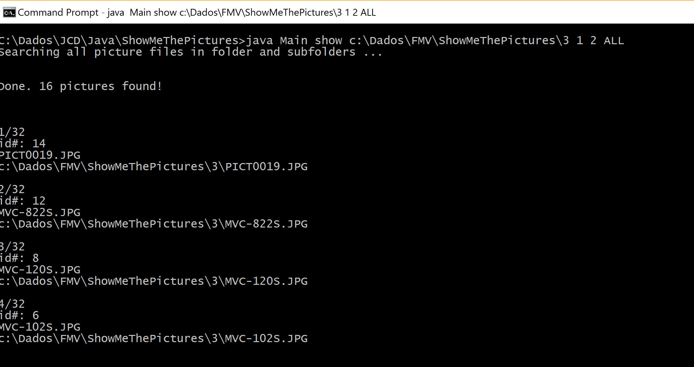

To show all picture files in a specific time

*Java Main show <pict_folder> ALL <total time>*

To show all picture files in one minute, we can run:

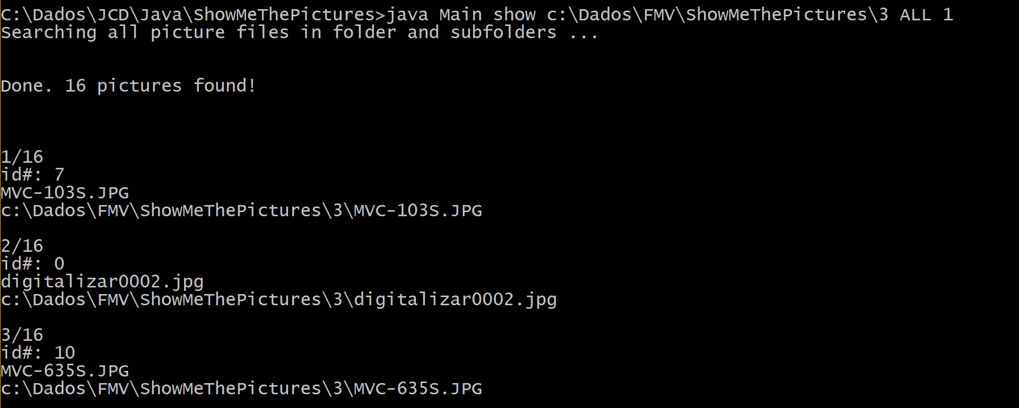

With 16 files, the interval will be around 4s (60/16).

To show picture files from a id list file

*Java Main show <picture_folder> <interval time> <id list file>*

Note: To get ids list all files (first command)

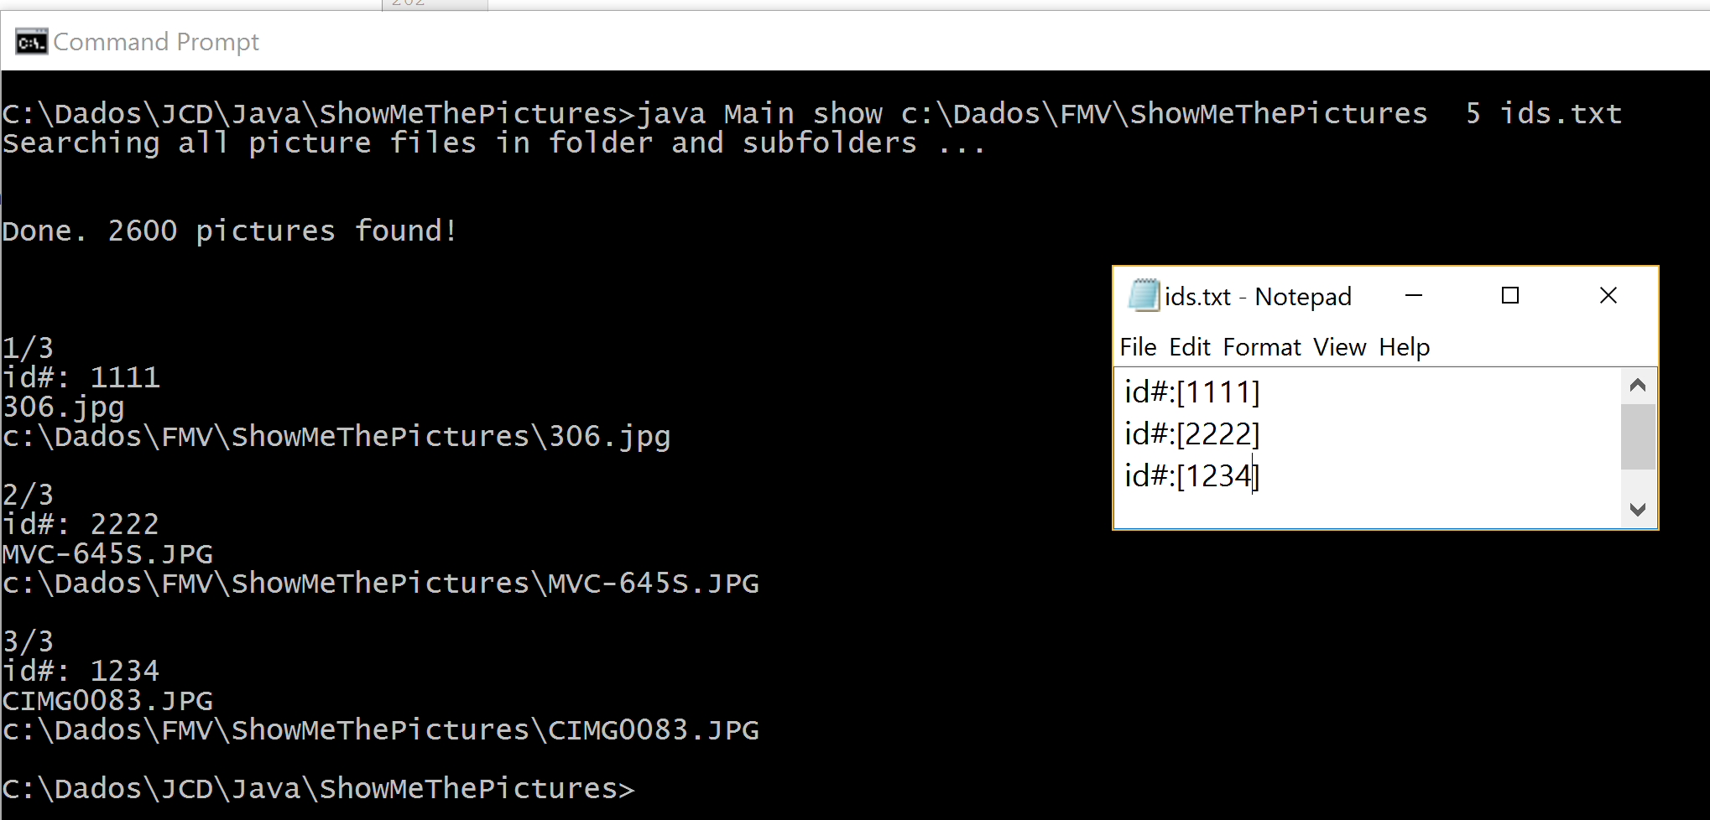

In the above screenshot, you can see 3 ids in the list and the 3 files with these ids were selected to show each 5 seconds.

To shuffle some picture files and copy to a folder

*Java Main copy <pic_folder> < numb.pics > <target folder>*

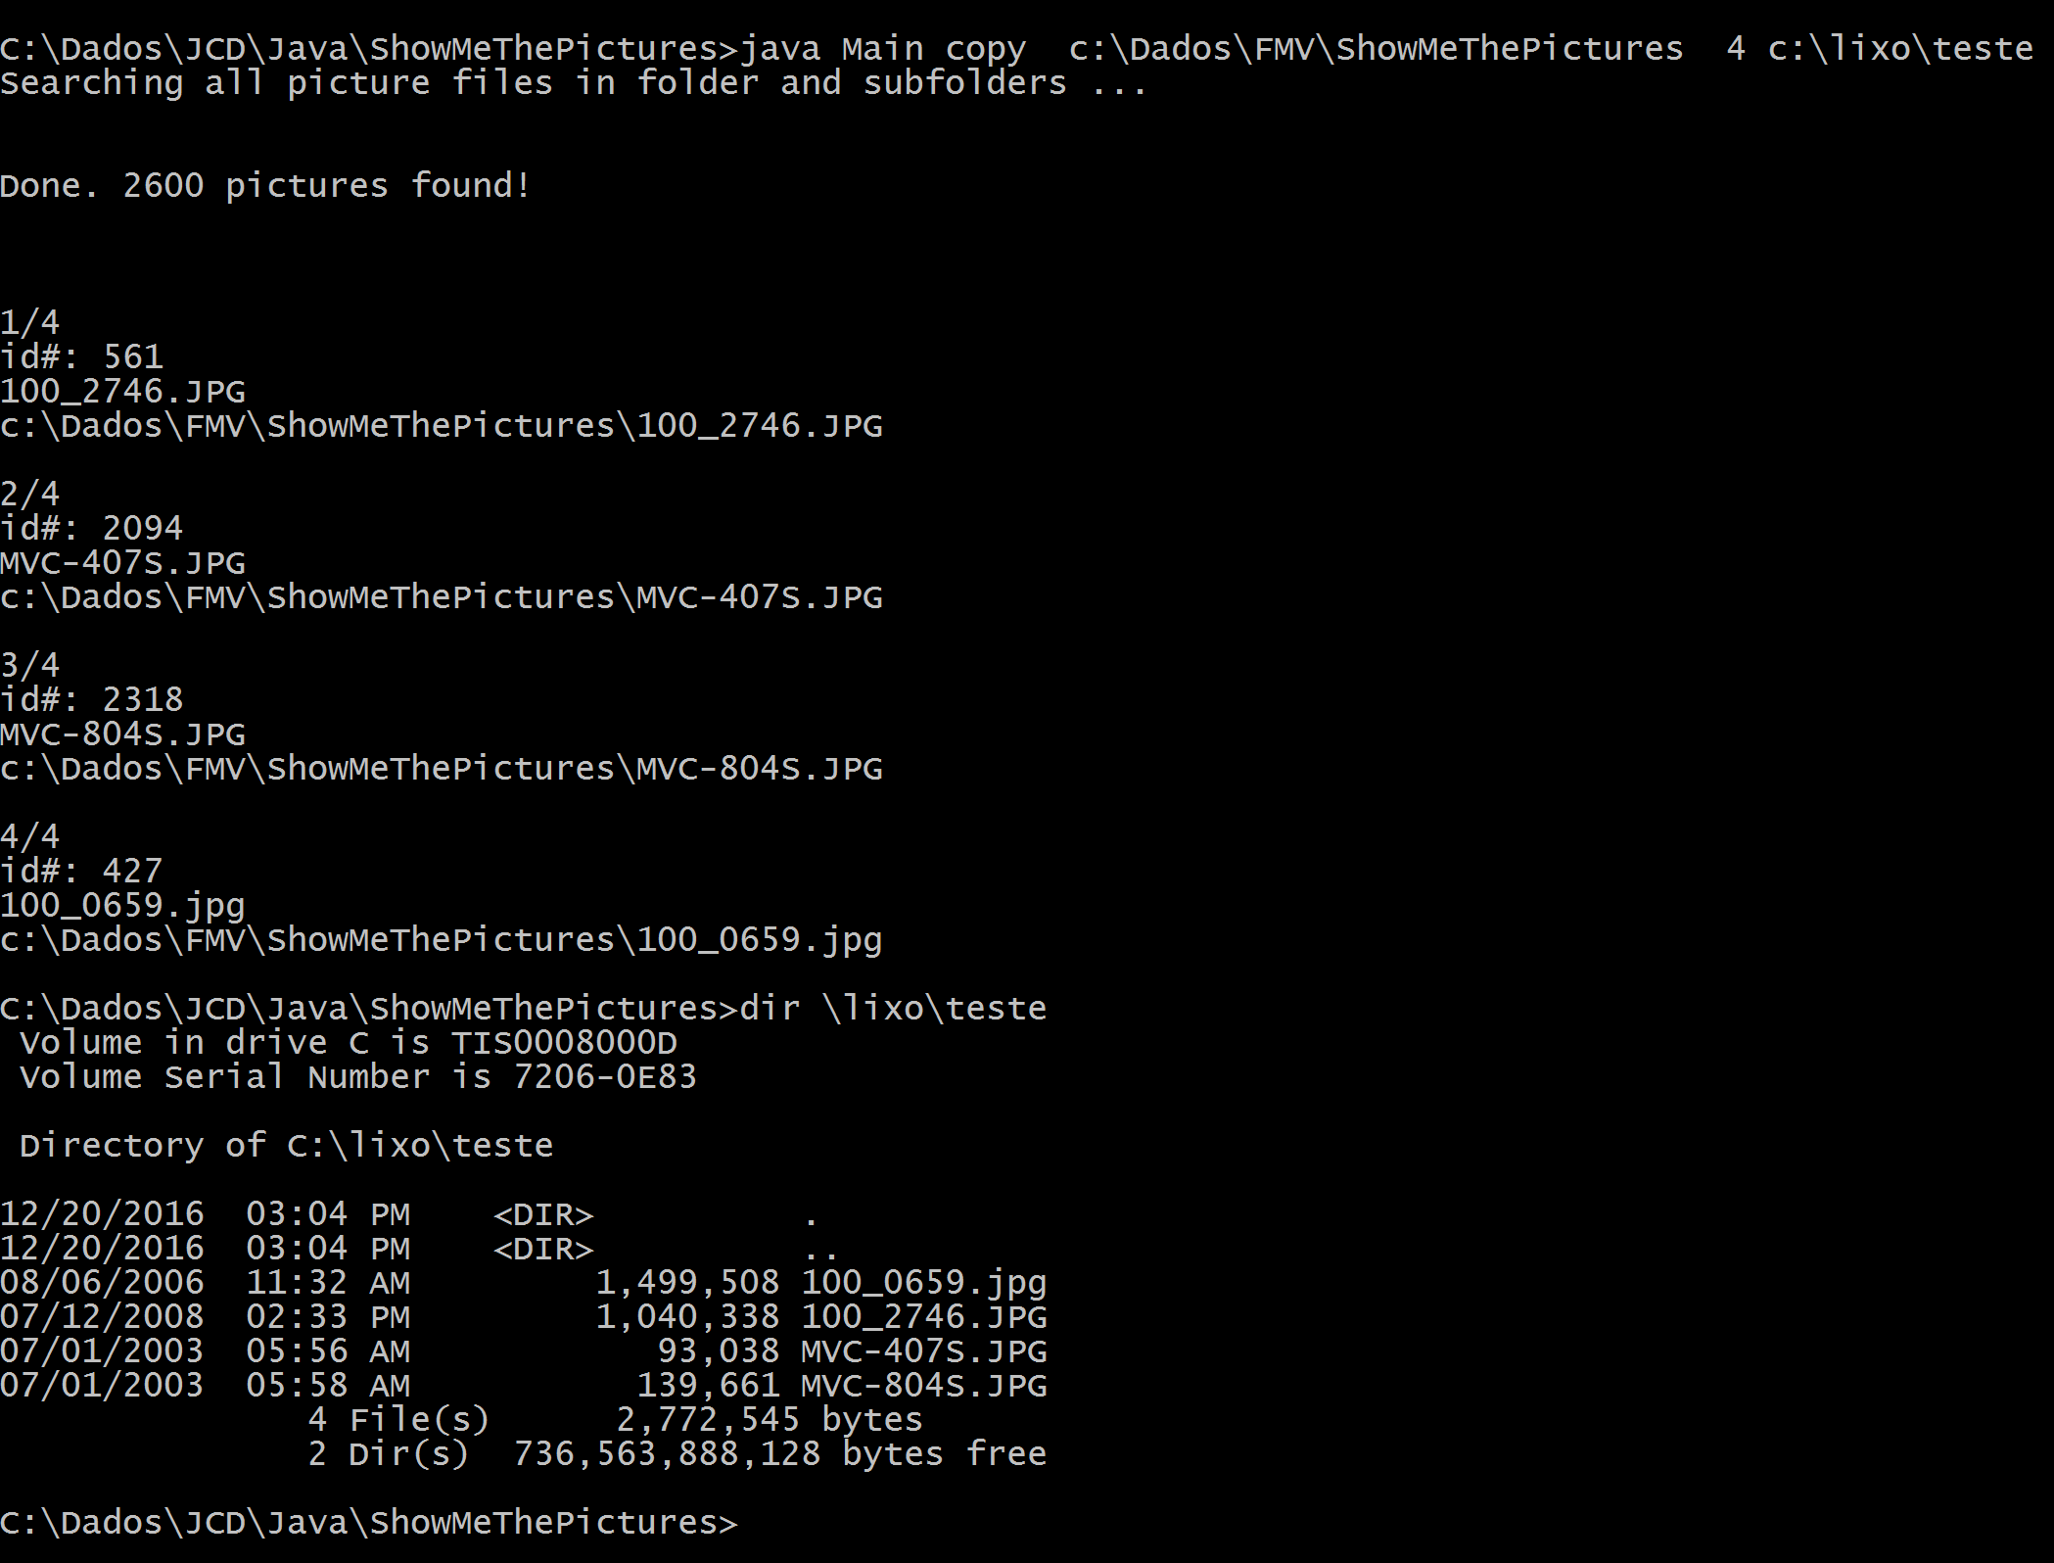

Above 4 random files were selected and copied to a folder

To copy picture files from a list to a folder

*Java Main copy <picture_folder> < id list file > <target folder>*

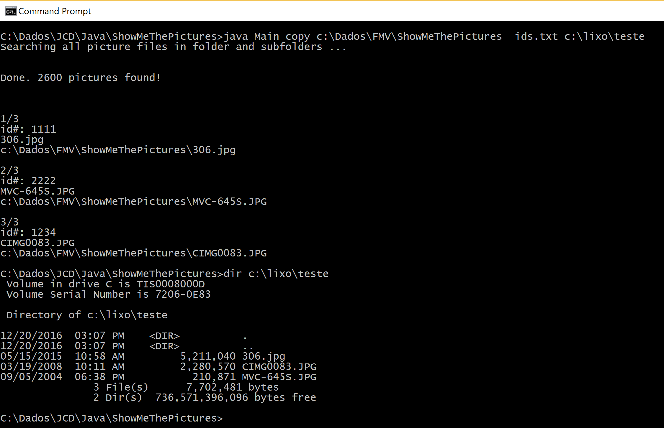

This time, 3 files defined in ID list file were copied to a folder.

To add sequence number to files copied to a folder

Use -n as last parameter like:

*Java Main copy <pic_folder> < num.pics > <target folder> -n*

*or*

*Java Main copy <pic_folder> < id list file > <target folder> -n*

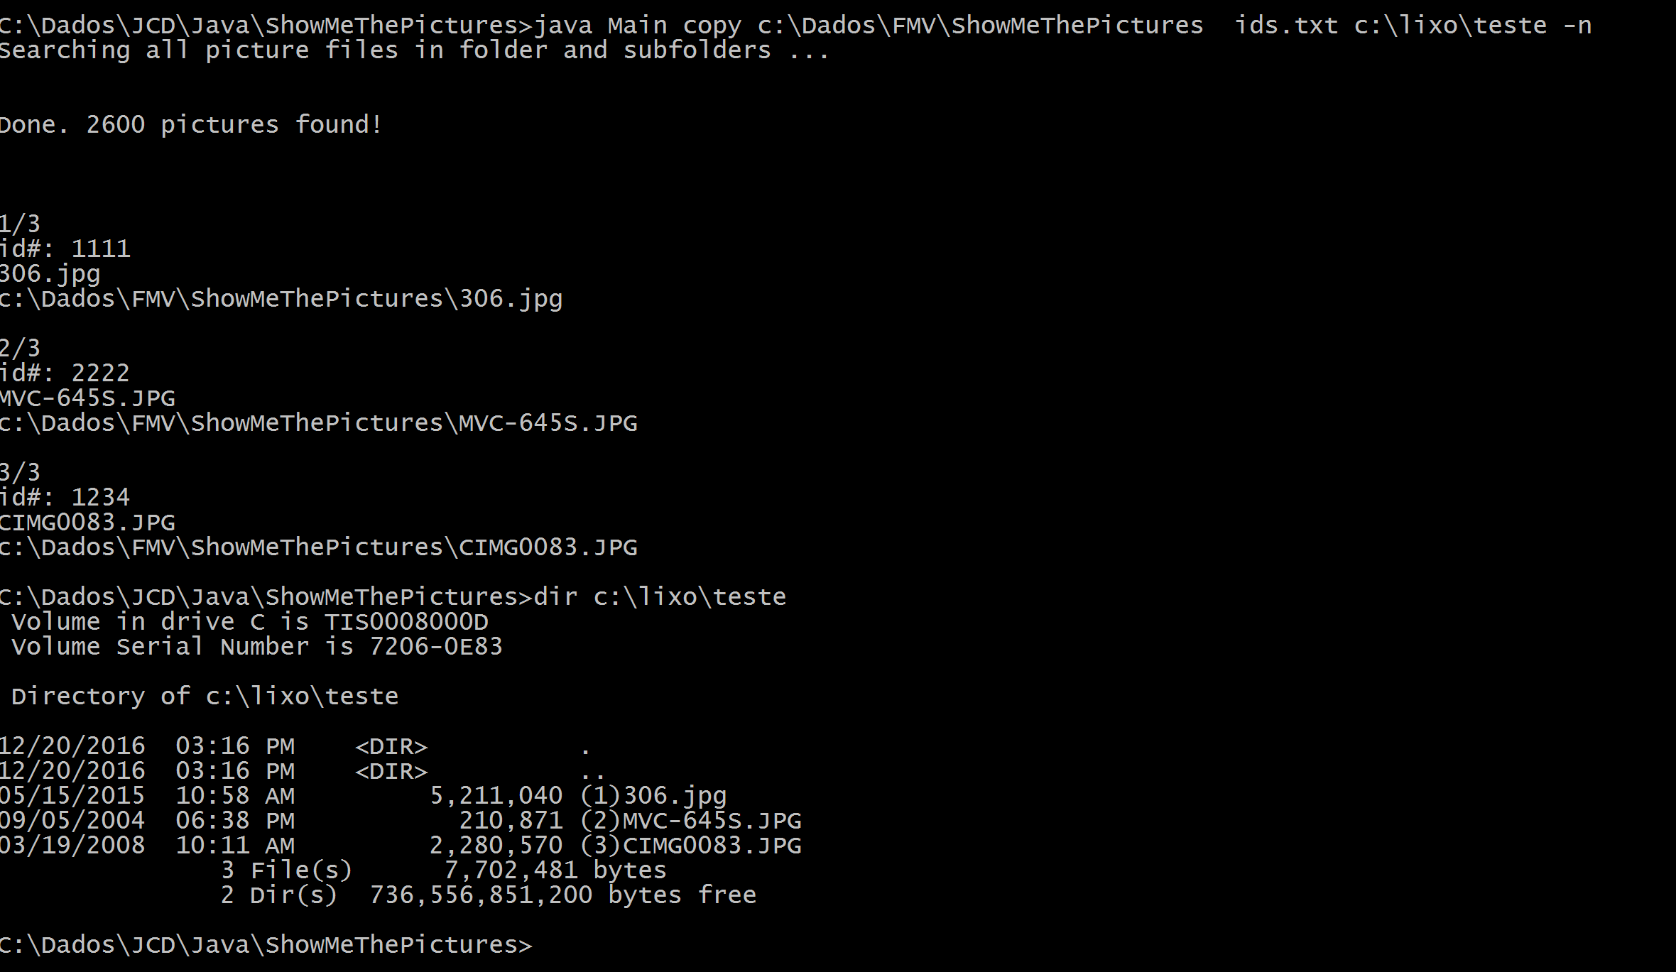

In the above screenshot, 3 files defined in the list were copied to a folder with a sequence number in the name.

This option is useful when you cannot shuffle the picture files. In this case, you can follow the sequence, since the sequence is already a random selection.

Questions/bugs: email [duartejc2001@hotmail.com](mailto:duartejc2001@hotmail.com)